New fitting series for
high-pressure instrumentation

Klingenberg, March 2022. For the instrumentation of high-pressure applications, WIKA has provided a new series of fittings and accessories. The fittings, under the model designation HPFA, are designed for pressures from 15,000 to 60,000 psi (1,034 to 4,136 bar).

HPFA parts can be combined with the corresponding ball or needle valves from WIKA. They enable a more flexible installation of measuring assemblies, even in confined locations. Versions with multiple outlets enable the instrumentation of measuring locations to be expanded individually. The new fittings are available from high-quality stainless steel in all commonly used versions. The fittings and accessories allow safe connections to high-pressure tubings, nipples, valves and instrumentation in general.

Furthermore, WIKA offers the customer-specific assembly of measuring instruments, valves and fittings. Such an “instrument hook-up” is delivered ready-to-install and leak tested.

Number of characters: 923
Key word: HPFA

Manufacturer:
WIKA Alexander Wiegand SE & Co. KG
Alexander-Wiegand-Straße 30
63911 Klingenberg/Germany
Tel. +49 9372 132-0
Fax +49 9372 132-406
vertrieb@wika.com
www.wika.de

WIKA company photograph:
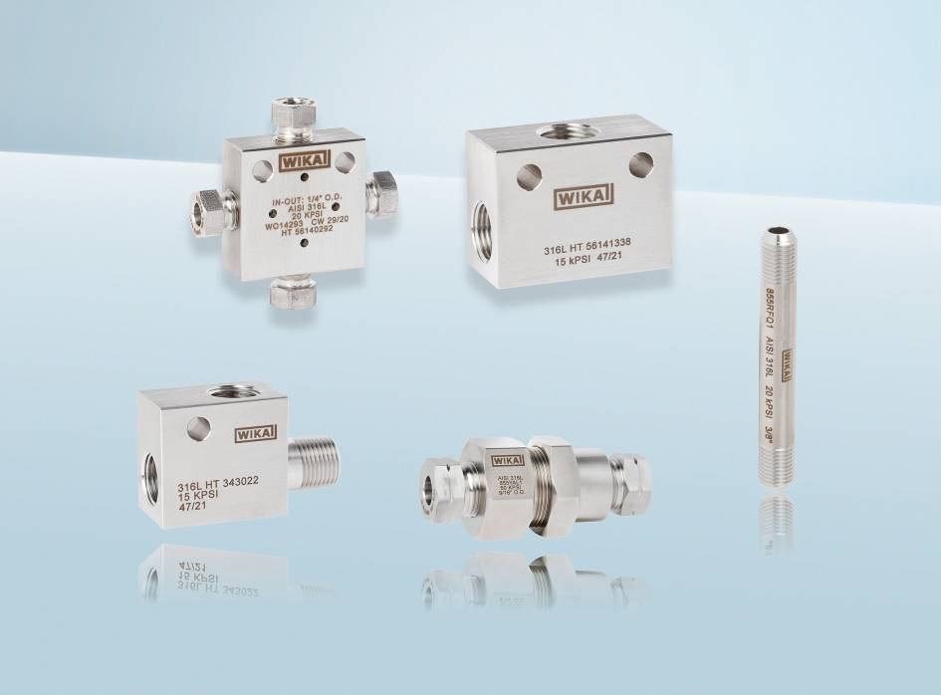
Model: HPFA

Edited by:
WIKA Alexander Wiegand SE & Co. KG
André Habel Nunes
Marketing Services
Alexander-Wiegand-Straße 30
63911 Klingenberg/Germany
Tel. +49 9372 132-8010
andre.habel-nunes@wika.com
www.wika.de

WIKA press release

