Pressure sensor module MTF-1
approved for Ex areas

Klingenberg, May 2022. The model MTF-1 pressure sensor module from WIKA is now also available in a version with ATEX and IECEx approval.

The new variant of the compact module supports manufacturers in their development of end products for applications in potentially explosive environments. Having ATEX and IECEx component certificates for the MTF-1 simplifies the Ex approval of the entire system.

Designed for pressures up to 1,000 bar, the pressure sensor module has features that enable it to be used in critical and sensitive applications. Its stainless steel measuring cell is welded to the process connection and therefore suitable for aggressive media. In addition, the “dry” and seal-free sensor element minimises the risk of contamination of the medium.

In the version with Ex approval, the model MTF-1 transmits the measured pressure value via an energy-saving I²C signal. The digital protocol also outputs a temperature value for the sensor. This information, in turn, can be used for condition monitoring of the end device.

Number of characters: 1.011
Key words: MTF-1 with Ex approvals

Manufacturer:
WIKA Alexander Wiegand SE & Co. KG
Alexander-Wiegand-Straße 30
63911 Klingenberg/Germany
Tel. +49 9372 132-0
Fax +49 9372 132-406
vertrieb@wika.com
www.wika.de

WIKA company photograph:
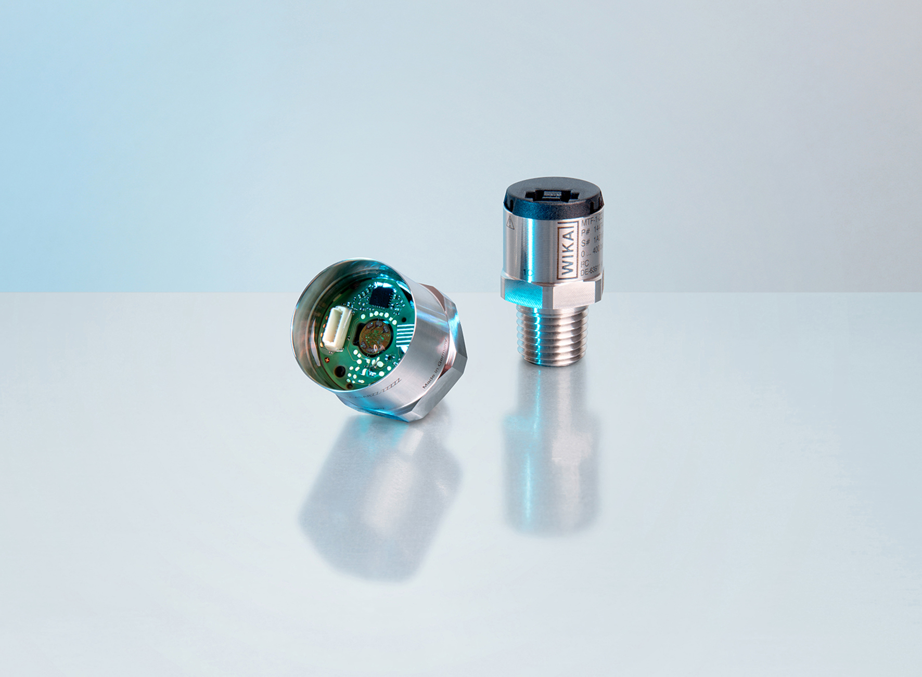
Model: MTF-1 with Ex approval

Edited by:
WIKA Alexander Wiegand SE & Co. KG
André Habel Nunes
Marketing Services
Alexander-Wiegand-Straße 30
63911 Klingenberg/Germany
Tel. +49 9372 132-8010
andre.habel-nunes@wika.com
www.wika.de

WIKA press release

