Hygienic
bimetal thermometer

Klingenberg, July 2022. The requirements of the pharmaceutical industry, the food industry and also biotechnology are met by the new bimetal thermometer from WIKA, the model TG58SA. The display instrument is in an ASME BPE-compliant design, meets the 3-A Sanitary Standard and has EHEDG and ATEX approval.

This makes the thermometer as flexible as it is globally applicable. The selection of industry-standard scale ranges and process connections (clamp, DIN 11864, VARINLINE®) also reflects this. All information about the connections is lasered on. In addition, the active length of the sensor is indicated on the dial to ensure correct temperature measurement.

The new measuring instrument, whose stem has a hemispherical bottom, can be cleaned in a process-safe manner in accordance with 3-A and EHEDG. It is suitable for CIP/SIP and wash-down processes.

The hygienic features of the TG58SA are complemented by a robust design. The thermometer offers a high overtemperature resistance. Its shatterproof window is also UV-resistant.

Number of characters: 1.008
Keyword: TG58SA

Manufacturer:
WIKA Alexander Wiegand SE & Co. KG
Alexander-Wiegand-Straße 30
63911 Klingenberg/Germany
Tel. +49 9372 132-0
Fax +49 9372 132-406
vertrieb@wika.com
www.wika.de

WIKA company photograph:
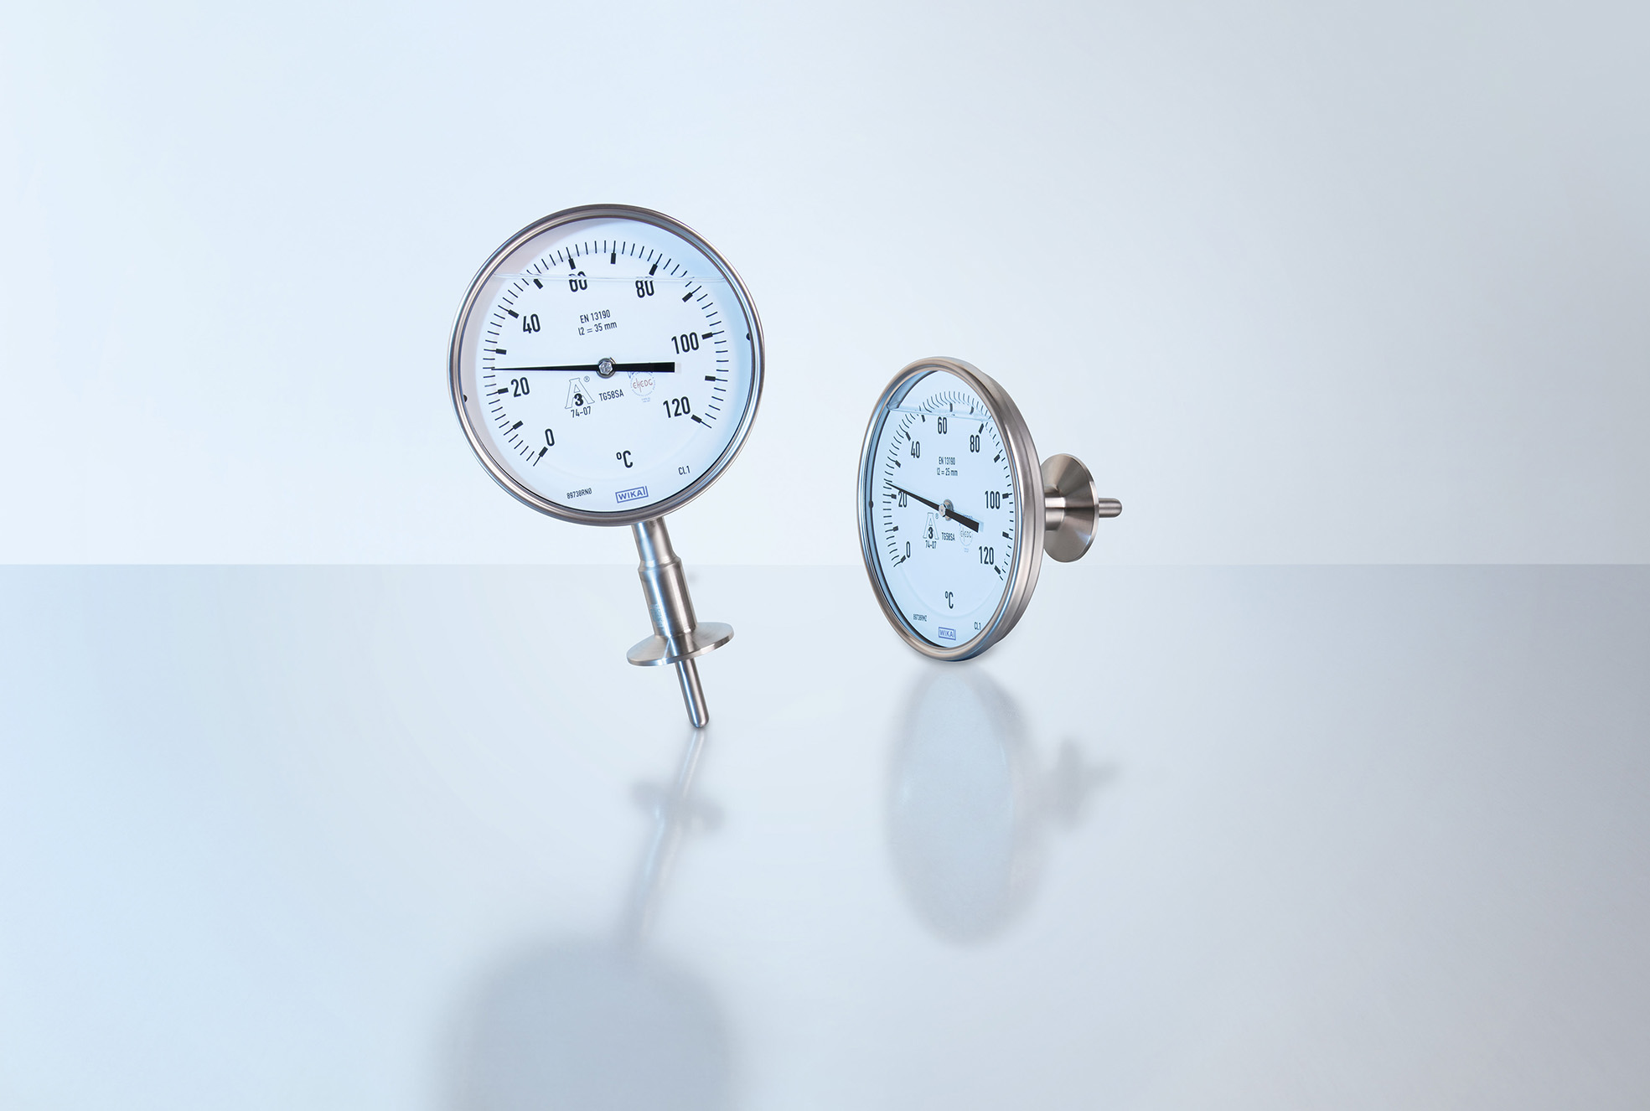
Model: TG58SA

Edited by:
WIKA Alexander Wiegand SE & Co. KG
André Habel Nunes
Marketing Services
Alexander-Wiegand-Straße 30
63911 Klingenberg/Germany
Tel. +49 9372 132-8010
andre.habel-nunes@wika.com
www.wika.de

WIKA press release

