WIKA certified to the ISO 19443 nuclear standard

Klingenberg, September 2022. WIKA has been certified by TÜV SÜD in accordance with the new ISO 19443:2018 quality management standard for civil nuclear projects. The measurement technology manufacturer is thus the first company in Germany, and the fourth worldwide, to achieve this status. The audit was passed at the first attempt.

So far, WIKA has been certified to KTA 1401. However, this standard was primarily designed for the German market. With its processes in accordance with ISO 19443, WIKA is now focusing on global project business in the civil nuclear power generation segment. Customer audits for qualification as a supplier can thus be widely reduced.

For the measurement requirements of the industry, WIKA offers products and customer-specific solutions for the measurement parameters of pressure, temperature and level.

Number of characters: 805
Keyword: ISO 19443

Manufacturer:
WIKA Alexander Wiegand SE & Co. KG
Alexander-Wiegand-Straße 30
63911 Klingenberg/Germany
Tel. +49 9372 132-0
Fax +49 9372 132-406
vertrieb@wika.com
www.wika.de

WIKA company photograph:
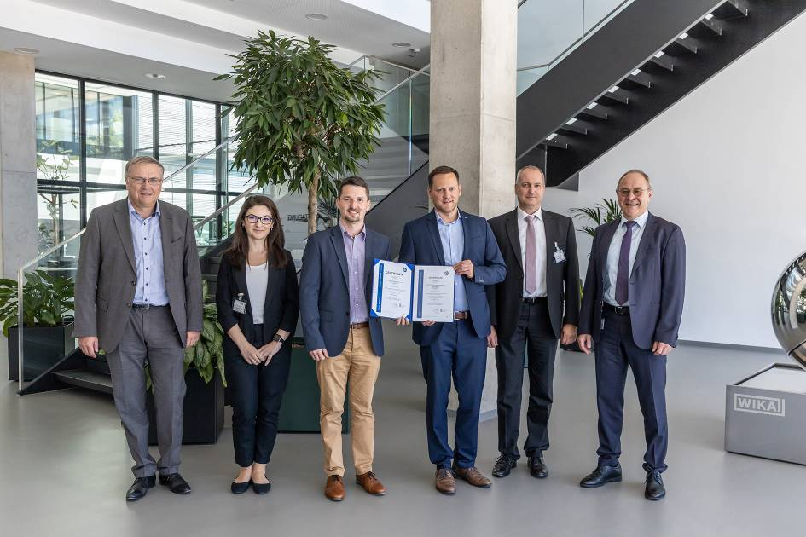
ISO 19443 quality management team

Edited by:
WIKA Alexander Wiegand SE & Co. KG
André Habel Nunes
Marketing Services
Alexander-Wiegand-Straße 30
63911 Klingenberg/Germany
Tel. +49 9372 132-8010
andre.habel-nunes@wika.com
www.wika.de

WIKA press release

