Wake frequency calculation
now in a web version

Klingenberg, January 2023. Online tool instead of Excel: WIKA now provides the wake frequency calculation for thermometer thermowells in accordance with ASME PTC 19.3 TW-2016 in a web-based version.

The new programme has adopted the proven and clear presentation of results from the previous Excel software. Access is via portal.wika.com/thermowell/.

Users have a choice - a freely accessible version allows the calculation for a single thermowell. With the full version, which requires registration and user verification, an unlimited number of thermowells can be calculated simultaneously. For reasons of data security, this registration takes place via Azure Active Directory B2C. A PDF function for documenting the calculation is included in both versions.

Number of characters: 733
Keyword: Wake frequency calculation

Manufacturer:
WIKA Alexander Wiegand SE & Co. KG
Alexander-Wiegand-Straße 30
63911 Klingenberg/Germany
Tel. +49 9372 132-0
Fax +49 9372 132-406
vertrieb@wika.com
www.wika.com

WIKA company photograph:
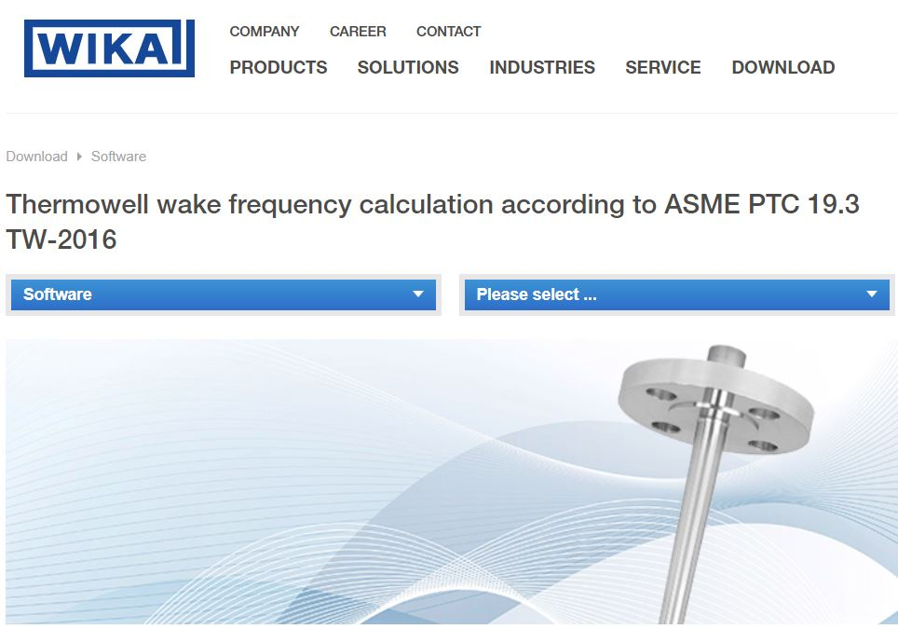
WIKA Software Thermowell

Edited by:
WIKA Alexander Wiegand SE & Co. KG
André Habel Nunes
Marketing Services
Alexander-Wiegand-Straße 30
63911 Klingenberg/Germany
Tel. +49 9372 132-8010
andre.habel-nunes@wika.com
www.wika.com

WIKA press release

