Electronic pressure switch
for hygienic applications

Klingenberg, March 2023. The PSD-4 electronic pressure switch is the universal solution for industrial automation tasks – also in hygienic applications and under harsh conditions.

Thanks to EHEDG and 3-A certification, the pressure switch is also suitable for industries with high hygienic requirements.

Due to an accuracy of < ±0.5 % and minimal long-term drift, it permanently ensures an accurate representation of the process pressure for more than 100 million load cycles. The pressure switch is available with a digital output signal as well as a switchable and scalable analogue output. In addition, it can also be easily monitored via the self-diagnostics.

Condition data and the diagnostic functions allow consistent monitoring. Pressure or temperature values that are above or below the specifications are displayed directly in the system. The data also allow conclusions to be drawn about changing process conditions. Additional information helps to check the loading.

The scalable analogue output enables the measuring range to be adapted at a ratio of 5:1. In addition, the output signal can be configured specifically for the application. Thus the PSD-4 can be used flexibly.

Number of characters: 1,160
Keyword: PSD-4

Manufacturer:
WIKA Alexander Wiegand SE & Co. KG
Alexander-Wiegand-Straße 30
63911 Klingenberg/Germany
Tel. +49 9372 132-0
Fax +49 9372 132-406
vertrieb@wika.com
www.wika.com

WIKA company photograph:
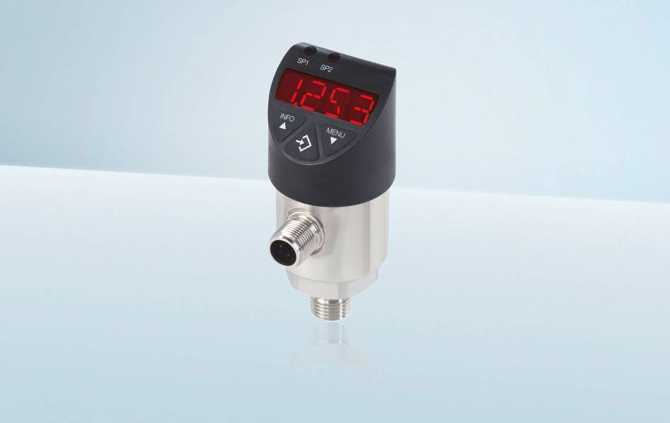
Model: PSD-4

Edited by:
WIKA Alexander Wiegand SE & Co. KG
André Habel Nunes
Marketing Services
Alexander-Wiegand-Straße 30
63911 Klingenberg/Germany
Tel. +49 9372 132-8010
andre.habel-nunes@wika.com
www.wika.de

WIKA press release

