New universal temperature transmitter with drift detection

Klingenberg, October 2023. The new model T38 digital temperature transmitter from WIKA enables extremely flexible and stable temperature measurement. The instrument offers a maximum of sensor connection combinations and a new type of drift detection. Head-mounted and rail-mounted versions are available in SIL and various Ex versions.

The temperature transmitter, fully developed in accordance with IEC 61508, is designed for general application. With it, users can monitor their processes more efficiently. In addition to a large number of standard sensor characteristic curves, WIKA's newly-developed True Drift Detection is implemented in the T38. This function immediately signals any deviation of the measured value from the characteristic curve.

The T38 has six sensor connection terminals that can be configured as required, giving users the greatest possible scope for combinations. With the head-mounted transmitter, specially designed trapezoidal terminals with a very large clamping area and access from the outside simplify the connection of sensors and the current loop.

All variants of the new transmitter can be programmed using the HART® protocol with a large number of open configuration tools. The T38 can also be parameterised quickly and easily via the USB interface using the PU-548 programming unit and WIKAsoft-TT software.

Number of characters: 1,318
Keyword: T38

Manufacturer:
WIKA Alexander Wiegand SE & Co. KG
Alexander-Wiegand-Straße 30
63911 Klingenberg/Germany
Tel. +49 9372 132-0
Fax +49 9372 132-406
vertrieb@wika.com
www.wika.com

WIKA company photograph:
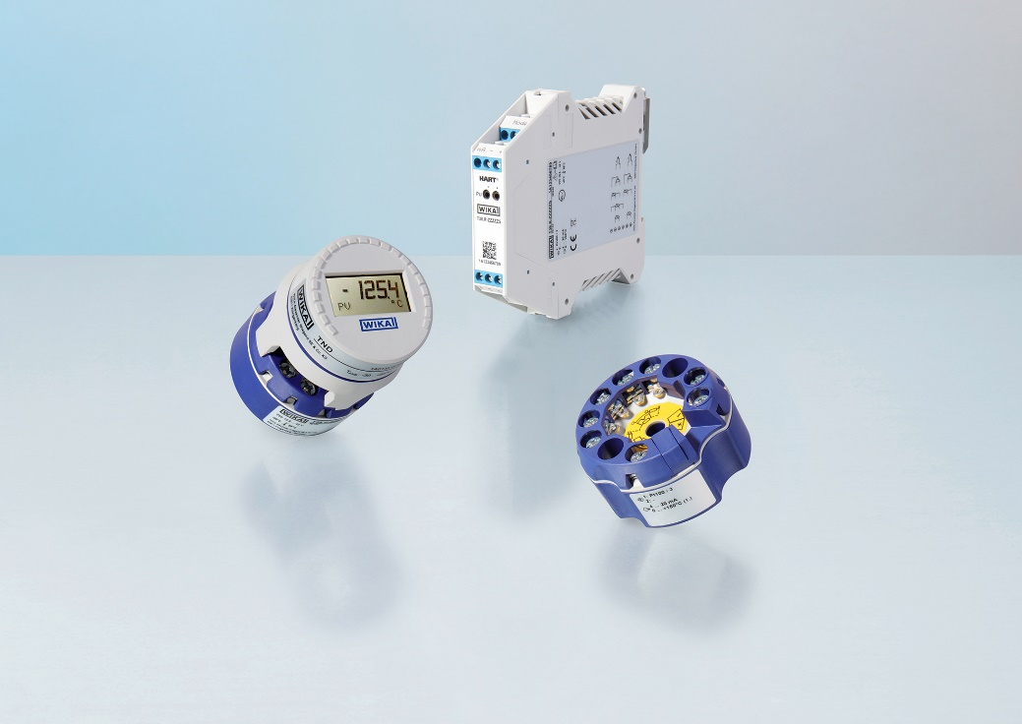
Model: T38

Edited by:
WIKA Alexander Wiegand SE & Co. KG
André Habel Nunes
Marketing Services
Alexander-Wiegand-Straße 30
63911 Klingenberg/Germany
Tel. +49 9372 132-8010
andre.habel-nunes@wika.com
www.wika.de

WIKA press release

