

GA11 gas analyser enables high-precision quality measurement of insulating gases
Highest accuracy and easy mobile handling

Klingenberg, July 2025. WIKA has launched the next generation of its GA11 gas analyser. It enables switchgear operators, manufacturers and maintenance companies to record the quality of SF6 gas and alternative insulating gases. The GA11 provides precise measured values for humidity, gas purity and decomposition products. Temperature-compensated sensing technology and intelligent measuring algorithms based on stability criteria ensure maximum accuracy when measuring cleanliness and dew point – a significant improvement on all previous versions. Optional sensing technologies for sulphur dioxide, hydrogen fluoride, hydrogen sulphide and carbon monoxide also offer high accuracy and long-term stability.
release

The new GA11 is suitable for mobile use thanks to its lighter, more compact design. The weight of the impact-resistant hard case, which is protected against water jets and dust in accordance with IP65, is just 22 kilograms. An integrated nickel-metal hydride (NiMH) rechargeable battery is also an advantage here. Unlike instruments with a lithium-ion rechargeable battery, the GA11 does not fall under the transport restrictions of the International Air Transport Association (IATA). The instrument can be carried on the aircraft as checked baggage – a plus point for international use.

Thanks to an intuitive user interface and clear menu navigation, all measurement processes are easy to control. All functionalities of the GA11 are available in both rechargeable-battery and mains operation. Last but not least, a closed measuring system reliably prevents emissions into the atmosphere: The measuring gas is either returned to the gas compartment or collected in an external gas recovery bag.
Press

Number of characters: 1,679

Manufacturer:
WIKA Alexander Wiegand SE & Co. KG Alexander-Wiegand-Straße 30
63911 Klingenberg/Germany Tel. +49 9372 132-0 info@wika.com www.wika.com

release

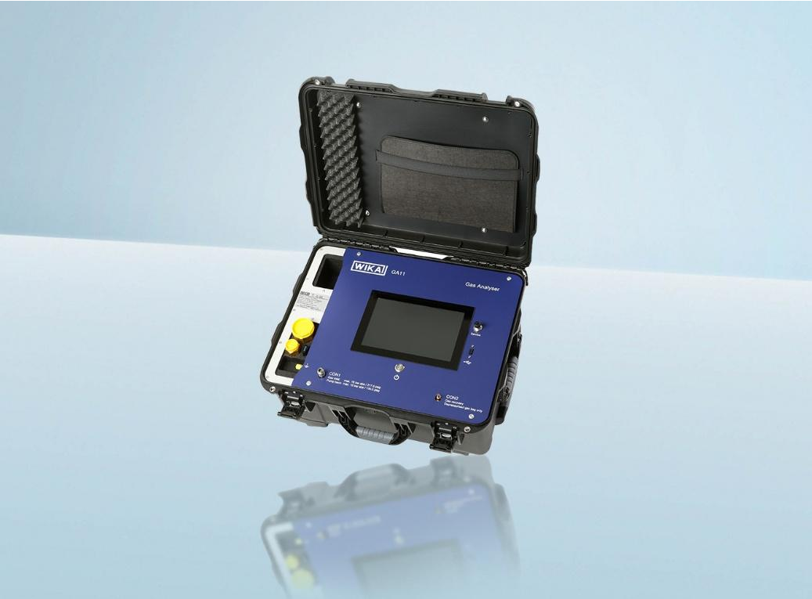
WIKA company photograph:

Edited by:
Press
WIKA Alexander Wiegand SE & Co. KG Andrea Suhrcke
Marketing Excellence Alexander-Wiegand-Straße 30 63911 Klingenberg/Germany Tel. +49 9372 132-8031 andrea.suhrcke@wika.com www.wika.com

WIKA press release

